“FCL e-book”: Table of Contents. V3.3
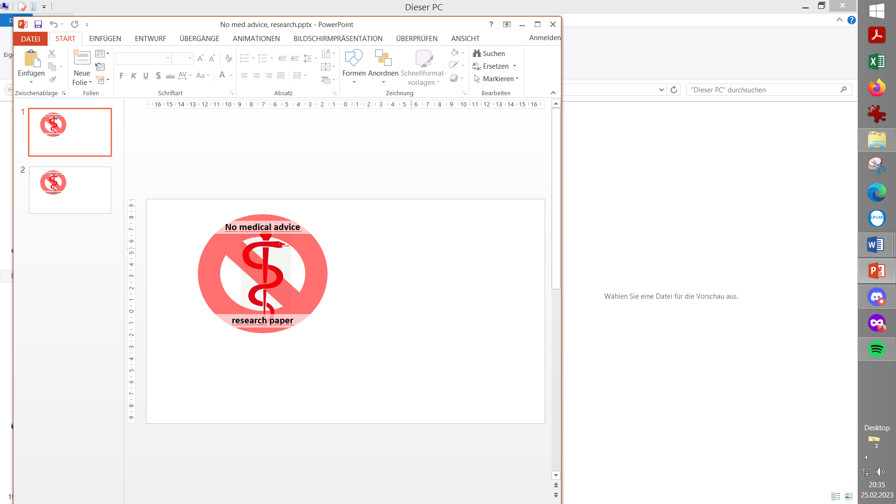

0. Introduction

1. Pre-requisites for Full Closed Loop
1.1 Well tuned hybrid closed loop
1.2 Fast insulin
1.3 Reliable insulin delivery from pump and cannula
1.4 Excellent CGM
1.5 Meal-related limitations?
1.6 Lifestyle-related limitations?
1.7 Time required for setting-up
Case study 1.1: Occlusion
Case study 1.2: Comparing insulins for FCL
Case study 1.3: Jumpy CGM
Case study 1.4: Lost pump connection
Case study 1.5: Permanent CGM values w/ 2x G6
Case study 1.6: When catastrophy strikes
Case study 1.7: MDI when the loop dies…
Case study 1.8: (placeholder for a Libre3 / 1.-minute case)…
…

2. General Settings for Full Closed Loop
2.1 SMB range extension
2.2 Max and min autoISF ratio
2.3 SMB delivery ratio
2.4 iobTH (iob_threshold_percent)
2.5 Eating Soon TT?
2.6 General settings in AAPS/Preferences

3. Description of autoISF / guidance by developers
3.1 Overview
3.2 ISF modulation flowcharts
3.3 Exercise mode and dynamic iobTH
3.4 Automation options with autoISF parameters
3.5 Activity monitor
3.6 Using one-minute CGM (Libre 3)
3.7 AutoISF parameters overview table
3.8 Emulator for logfile analysis and tuning
3.9 Links to related case studies/detailed doc.s

4. Meals: Setting ISF_weights in AAPS/Preferences
4.1 Getting started
4.2 bgAccel_ISF_weight
4.3 pp_ISF_weight
4.4 bgBrake_ISF_weight
4.5 dura_ISF and bg_ISF
4.6 Tuning your initial settings
4.7 Complex scenarios
4.8 Profile helper
Case study 4.1: Pizza
Case study 4.2: Low carb meals
Case study 4.3: Hands-off FCL around Christmas

5. Temp. modulation of autoISF aggressiveness
5.1 Automatic modulation of loop aggressiveness
5.1.1 autoISF off outside of meal windows
5.1.2 SMB off @ odd profile target
5.1.3 SMB off @ odd temp. target
5.1.4 Automatic diff. of FCL aggressiveness via Automations
5.1.5 Automatic diff. of FCL aggressiveness via Activity Monitor
5.1.6 Diff. of aggressiveness using “Automation State”
5.1.7 Pro/con completely hands-off FCL
5.2 Manual modulation of FCL aggressiveness via DIY cockpit
5.2.1 Status recognition
5.2.2 Manual interventions from DIY cockpit
5.2.2.1 Temp. %profile or TT settings
5.2.2.2 Temp. settings in /preferences
5.2.2.3 Grey DIY cockpit buttons for pre-programmed FCL responses
5.2.3 Temporary exit from FCL
5.3 Recognizing loop state from the AAPS home screen
5.3.1 Modulated loop aggressiveness (3 top buttons)
5.3.2 Color scheme of the top 3 buttons
5.3.3 Active Automations
5.3.4 FCL related indicator fields
5.3.5 Overall AAPS home screen
5.3.6 Extra graphs for autoISF
5.3.7 Info given every 5 minutes in the SMB tab
5.3.8 Info about last 15 autoISF decisions
5.3.9. SMB tab info when operating 1-minute Libre
Summary: Your personal FCL cockpit

Case study 5.2: Sweet snacks / Glühwein w/ DIY cockpit
Case study 5.3: Compression low

6. Temp. modulation for exercise and light (In-)activity
6.1 Dynamic iobTH and sensitivity ratio
6.1.1 Manual (direct) iobTH modulation
6.1.2 Automations for iobTH modulation
6.1.3 Dynamic iobTH
6.2 Temp. % profile switch
6.3 DIY cockpit based on User action Automations
6.4 Improved FCL cockpit
Skip what is in green writing: = Drafted fragments or not implemented ideas.
(Might be weeded out soon, many things not really needed)
6.4.1 Manual (direct) iobTH modulation
6.4.2 pre-set 4 kinds of exercise
6.4.3 optional meal pre-sets
6.4.4 optional hypo management pre-sets
6.5 Mastering the exercise after meal challenge
6.5.1 Manual mode
6.5.2 DIY cockpit button for User action Automation
6.5.3 Using pre-sets in improved FCL cockpit
6.6 Activity monitor based on step-counter
Case study 6.2 Biking day with hi carb lunch; DIY cockpit

7. Advanced HCL (meal announcement via pre-bolus)
7.1 Hurdles for FCL
7.2 Getting ready to advance from HCL
7.3 Reduced pre-bolus
7.4 Tuning autoISF in HCL
7.5 Dealing with disturbances/ins. sens/resistance
7.6 Exercise management
7.7 Remote control (small children) (fragment, to be completed /NN)
7.8 Other methods w/ meal announcement (MA)
Case study 7.1: Meal Announcement (5y old)

8. Performance monitoring and tuning
Case study 8.2: Futility of tuning based on 1 extreme meal

9. Trouble shooting
Case study 9.1: Un-intended loss of loop aggressiveness

10. Emulator on PC to determine settings
10.1 Installing the Emulator on your PC
10.2 Analyzing loop decisions in logfiles
10.3 What-if analysis

11. Emulator on the smartphone
11.1 Installing the emulator on your smartphone
11.2 Checking loop decisions on the smartphone
11.3 Options available on i-Phone (for Trio or iAPS)
11.4 Real-time checking a „what-if“ question using speech synthesis

12. Remarks for users of previous autoISF version

13. Other avenues to Full Closed Loop
13.1 FCL using AAPS Master and Automations
Case study 13.1: Comparison: 1 month FCL, using Automation vs autoISF
13.2 dynamicISF used for Full Closed Loop
Case study 13.2: Using dynISF for FCL (sorry, nobody provided interpretable data yet)
13.3 Methods involving simple meal announcement that might be stretched into a FCL
13.3.1 Boost
Case study 13.3: Boost-based FCL for a child
13.3.2 AIMI,
13.3.3 EatingNow
13.3.4 Tsunami
13.4 No-bolus looping with precise carb inputs
13.5 Machine Learning (AI)
13.6 Dual hormone systems
13.7 Co-Medications that might facilitate FCL

